PERFORMANCE REVIEW / DISTRICT PROFILE

1.1: INTRODUCTION
Upper West Akim District was carved out of West Akim Municipal by L.I. 2126 in 2011 under the auspices of the late former president of the Republic of Ghana, His Excellency John Evans Atta Mills. The Upper West Akim District Assembly (UWADA) was officially inaugurated on 30th June, 2012. It forms part of the thirty-three (33) Municipals and Districts Assemblies in the Eastern Region of Ghana.
The Upper West Akim District Assembly (UWADA), like all other Metropolitan, Municipal and District Assemblies in Ghana is mandated to prepare a 4-year Medium Term Development Plan (DMTDP) as a basis for the overall development of the District. The development plan currently being implemented (2018-2021 DMTDP) was prepared under the Medium Term National Development Policy Framework (MTNDPF 2018-2021) known as An Agenda for Jobs: Creating Prosperity and Equal Opportunities for All. This plan would elapse by end of 2021, hence paving way for the next successive medium term development plan for the next planning period (2022-2025) to be prepared.
In the light of this, it is imperative to review the 2018-2021 DMTDP as a basis for the preparation of the new DMTDP 2022-2025 to assess the extent of implementation of planned programmes and projects, and the achievement of set goals and objectives pertaining to Upper West Akim District.

1.1.1 VISION
"An effective and efficient development oriented Local Government institution ".

1.1.2 MISSION
"To improve the quality of life of its inhabitants through the provision of quality services and durable socio-economic infrastructure in a transparent and accountable manner".

1.1.3 CORE VALUES
The core values of the District Assembly are the principles, standards and rules of professional behaviours that guide the decisions, procedures and systems of the organization: These are:
- Anonymity and Permanence
- Client Orientation, Loyalty and Commitment
- Transparency and Accountability
- Diligence, Disciplines and Timeliness
- Creativity and Innovativeness
- Equity and Impartiality
- Integrity

1.2: PERFORMANCE REVIEW OF THE 2018-2021 DMTDP
The aim of the review of the 2018-2021 DMTDP is to determine the status of the implementation of the plan, its achievements, challenges and constraints to implementation, key issues/gaps associated with the plan implementation and its implications on the next planning period.
Departmental reports and the Annual Progress Reports for the period of 2018 to 2020 were used for the review of the Plan. The tables presented below show the outcomes or results of the implementation of the 2018-2021 DMTDP.

Table 1: Agriculture
Development Dimension | Indicator | Baseline  (2017) | 2018-2021 Medium Term Target | Development Outcomes
 |  |  |  | Year | Data
Economic Development | 1. Proportion of registered businesses | N/A | 60% | 2021 | 50.68%
Economic Development | 2. Extension officer : farmer ratio | 1:2100 | 1:1500 | 2021 | 1:4169
Economic Development | 3. Average productivity of selected crop (Mt/Ha):  - Cassava  - Maize  - Plantain  - Rice | 18.50  11.54  7.20  - | 35.0  20.0  15.0  - | 2021 | 31.0  3.7  10.34  3.45
Economic Development | 4. Change in yield of selected crops (%):  - Cassava  - Maize  - Rice  - Yam  - Plantain | 21005  19,564  -  -  - | 20% (25,206)  20% (23,476.8)  - | 2021  2021 | 243,350  33.1% (26,049)  57.76  11,990.8  43,080
Economic Development | 5. Change in yield of selected livestock  - Poultry  - Goat  - Sheep  - Pig | 12,000  7,500  4,500  2,500 | 20% (13,800)  15% (8,250)  15% (4,950)  15% (2,750) | 2021 | 465% (67,820)  -50% (3,767)  -59.3% (1832)  0% (2,500)
Source: DoA-UWAD, 2021 Report

Table 2: Education
Development Dimension | Indicator | Baseline  (2017) | 2018-2021 Medium Term Target | Development Outcomes
 |  |  |  | Year | Data
Social Development | 1. Gross enrolment rate:  - K.G  - Primary  - JHS | 94.5%  93.6%  66.1% | 97%  98%  76% | 2021 | 97%  86%  65%
Social Development | 2. Net enrolment rate:  - K.G  - Primary  - JHS | 76.9% | 80% | 2021 | 75%
Social Development | 3. Gender Parity Index:  - K.G  - Primary  - JHS | 0.97%  0.96%  0.91% | 1.0%  1.0%  1.0% | 2021 | 0.97%  1.01%  0.96%
Social Development | 4. Pass Rate:  - B.E.C.E.  - W.A.S.S.C.E. | 49%  N/A | 53%  N/A | 2021 | 52.43%  65.60%
Source: DoE-UWAD, 2021 Report

Table 3: Health Care Delivery
Development Dimension | Indicator | Baseline  (2017) | 2018-2021 Medium Term Target | Development Outcomes
 |  |  |  | Year | Data
Social Development | - OPD Attendance Rate | 56.4% | 80% | 2021 | 40.5%
Social Development | - Immunization coverage (Penta3) | 80% | 92% | 2021 | 91.4%
Social Development | - Antenatal Care coverage (at least one visit) | 39.6% | 65% | 2021 | 61.2%
Social Development | - Percentage of supervised deliveries | 16% | 25% | 2021 | 32.2%
Social Development | - Under-five mortality rate | 0 | 0 | 2021 | 0
Social Development | - Malaria case fatality in children under 5years | 0 | 0 | 2021 | 0
Social Development | - Maternal mortality rate | 0 | 0 | 2021 | 0
Social Development | - Tuberculosis incident rate | 25% | 30% | 2021 | 31.89%
Social Development | - Tuberculosis cure success rate | 53.7% | 60% | 2021 | 92.1%
Social Development | - Nurse: population ratio | 1:1057 | 1:832 | 2021 | 1:838
Social Development | - Doctor: population ratio | 0:99895 | - | 2021 | 0
Social Development | - ITN Coverage (children under 5years) | 97.2% | 100% | 2021 | 69.8%
Social Development | - ITN Coverage (pregnant women) | 90.8% | 100% | 2021 | 99.4%
Social Development | - Contraceptive prevalence rate | 22.5% | 31% | 2021 | 36.70%
Social Development | - HIV prevalence rate (male/female) | 1% | 0.5% | 2021 | 0.10%
Social Development | - HIV prevalence among pregnant women | 2 | 2 | 2021 | 1.02%
Source: DHS-UWAD, 2021 Report

Table 4: Water and Sanitation
Development Dimension | Indicator | Baseline  (2017) | 2018-2021 Medium Term Target | Development Outcomes
 |  |  |  | Year | Data
Social Development | - Proportion of population with sustainable access to safe water sources | 66% | 75% | 2021 | 69%
Social Development | - No. of Open Defecation Free communities | 0 | 15 | 2021 | 0
Social Development | - Proportion of population with access to improved sanitation (flush toilets, KVIP, household latrine) | 45% | 69% | 2021 | 47%
Source: DWST-UWAD, 2021 Report

Table 5: Social Protection
Development Dimension | Indicator | Baseline  (2017) | 2018-2021 Medium Term Target | Development Outcomes
 |  |  |  | Year | Data
Social Development | - No. of welfare cases handled:  - Child custody  - Maintenance | 120:  12  108 | 50:  2  48 | 2021 | 37:  4  33
Social Development | - No. of trained and empowered women who are self-employed or self-dependent | 6 | 33 | 2021 | 32
Social Development | - No. of seats held by women in the District Assembly (Assembly Members) | 3 | 10 | 2021 | 4
Source: DSWCD-UWAD, 2021 Report

Development Dimension | Indicator | Baseline  (2017) | 2018-2021 Medium Term Target | Development Outcomes
 |  |  |  | Year | Data
Environment, Infrastructure and Human Settlement | Feeder roads condition mix (km)  - Good:  - Fair:  - Poor: | 19.6  24.4  66.0 | 70  50  40 | 2021 | 45km  65km  10 km
Environment, Infrastructure and Human Settlement | No. of road crashes/accidents  - Fatal accidents  - Casualties | 10 | 3 | 2021 | 41  13  28
Source: DWD, 2021.

Development Dimension | Indicator | Baseline  (2017) | 2018-2021 Medium Term Target | Development Outcomes
 |  |  |  | Year | Data
Governance, Corruption and Public Accountability | Police - citizen ratio | 1:4500 | 1:1500 | 2021 | 1:2500
Governance, Corruption and Public Accountability | No. of reported crime cases:  - Civil  - Criminal | 2  255 | 0  50 | 2021 | Nil  153
Source: DPCU, 2021.

Table 6: Financial Performance 2018-2021
Source of Funds | Total Estimated cost of Plan | Total Amount Received | Variance
GOG | 8,759,215.76 | 6,613,636.33 | (2,145,579.43)
IGF | 2,518,290.00 | 2,144,609.45 | (373,680.55)
DACF | 15,778,001.44 | 5,793,154.63 | (9,984,846.81)
DACF-RFG | 3,229,724.34 | 1,952,689.40 | (1,277,034.94)
DPs  AGRIC. DONOR | 566,310.08 | 421,000.48 | (145,309.60)
OTHERS
DACF-MP | 1,500,000.00 | 1,048,413.53 | (451,586.47)
PWD | 882,453.00 | 655,696.31 | (226,756.69)
TOTAL | 33,233,994.62 | 18,629,200.13 | (14,604,794.49)

1.3 KEY CHALLENGES ENCOUNTERED DURING THE PLAN IMPLEMENTATION
- Inadequate and delay in the release of funds especially, District Assembly Common Funds (DACF) and DACF-RFG, coupled with inadequate revenue generated from the Internally Generated Funds (IGF) affected the implementation of the plan
- The incidence of COVID-19 outbreak also caused some major changes in to the plan implementation
- Uncompleted/abandoned projects (DA, MP, GETFUND, IPEP, GHANA FIRST etc)
- Inadequate logistics such as vehicles, for monitoring and evaluation exercise
- Boundary disputes, especially with West Akim Municipal Assembly.
- Frequent power outages disrupting economic and administrative activities.
- Inadequate staff (some departments), inadequate office equipment (computers, printers, scanners, photocopy machines etc).
- Inadequate office accommodation and lack of residential accommodation for key DA staff.
- Non-functionality of sub-district structures
- Uncoordinated and poor implementation of some key development programmes e.g. GSFP, IPEP, etc.
- Delay in submission of AAPs and reports by some Departments of the Assembly
- Political interference and politicization of development programmes and projects e.g. GSFP, IPEP, NaBCO etc.

1.4 PROFILE AND SITUATIONAL ANALYSIS

1.4.1: LOCATION AND SIZE
Upper West Akim District is located in the south western part of Eastern Region and has a total land size of about 342.3 km2. The district shared boundary with eight (8) districts thus, Ayensuano District, located on the east, West Akim Municipal to the north, Birim Central Municipal on the south-west, Agona East and Awutu-Senya West on the west, Nsawam-Adoagyiri, Ga West Municipal and Ga South Municipal on the south-east.
Adeiso is the administrative capital of the district and is located along the main Nsawam-Asamankese highway. The district's location is strategically unique and can promote local economic development because of its proximity and easy accessibility to both the national (Accra) and regional (Koforidua) capitals. The district is also a strategic location for investment opportunities like agriculture and agri-business, tourism and entertainment, real estate development, health and educational infrastructure development.
The development issues however, confronting the district with regards to its location is the poor road networks in the rural areas and also boundary disputes with neighbouring districts most especially West Akim Municipal Assembly which is always collecting revenues meant to be collected by Upper West Akim District. There is the need for the Assembly to solicit for support from other government agencies, development partners and philanthropists to have most of the feeder roads fixed so as to attract more investors, and also liaise with the E.R.C.C. and the MLGDRD to resolve the boundary issues.
Figure 1 shows the district map of Upper West Akim.

Figure 1: Map depicting the size and boundaries of Upper West Akim District
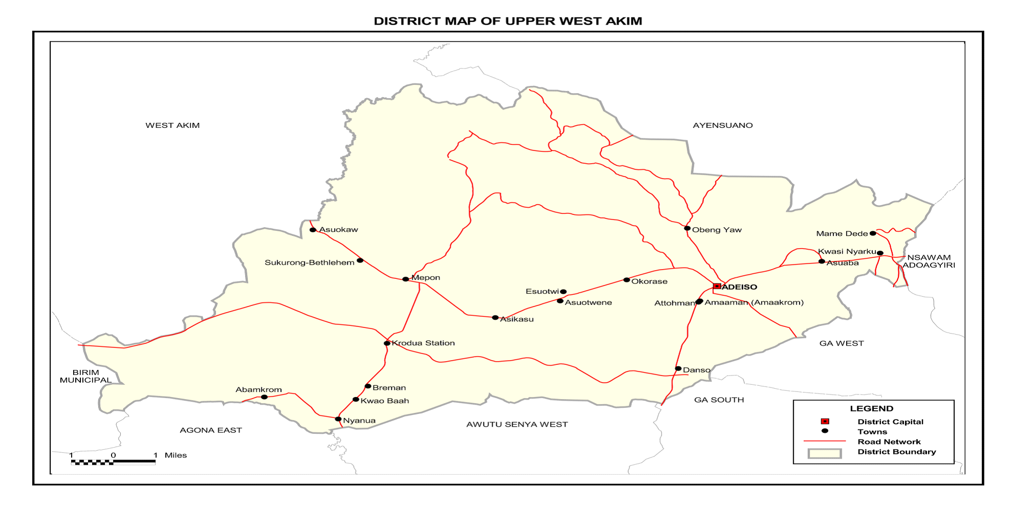Source: Ghana Statistical Service. GIS – 2010

1.4.2: Climate
The district lies within the wet-semi equatorial climatic zone which receives rainfall between 1238mm and 1660mm. This is characterized by a bi-modal rainy season which supports all-year round plant growth. The major rainy season is from March to June with the heaviest rainfall in June, and minor raining season from September to October.
The average temperature ranges between 25.2⁰C (minimum) and 27.9⁰C (maximum). Relative humidity is highest during the rainy season of about 80-95% and 55-80% during the dry season. The fair distribution of temperature and rainfall patterns supports the cultivation of many food and cash crops throughout the district. The serene atmosphere and the weather condition is also idle for the promotion of tourism in the district.

1.4.3: Vegetation
The District lies within the semi-deciduous forest zone. The vegetation is mainly characterized by tall trees with evergreen undergrowth and contains valuable economic trees like Odum, Wawa, Sapele, Obeche, Onyina, Emire and others. Most of the trees shed their leaves during the dry season. The district has broken forest on most hill tops, secondary forest on slopes and valleys, shrubs and bushes along the motor roads and main footpaths, thickets on the range facing the Adeiso Township and forest reserves. There are two major forest reserves, forest patches and sacred groves scattered all over the district. Notable ones can be found in towns such as Adeiso-Alafia called Korklofa, Okainkrom-Tigara and Afarikrom.
There is however rapid increase in some human activities which is gradually depleting the economic value of the vegetation. Activities such as illegal sand-winning, bad farming practices, illegal chainsaw operations, and haphazard building/real estate activities are currently depleting some of these natural vegetation cover and it is affecting the sustainability of the green vegetation and contributing to climate change.
Measures such as public sensitization/education on climate change issues, planting of more trees, enactment and enforcement of bye-laws to protect the vegetation would have to be undertaken seriously to address these problems.

1.4.4: Topography and Drainage
The topography of the District is generally undulating with heights ranging between 60 meters and 460 meters above sea level. The Atewa Range runs through the east of the district and serves as a boundary between Upper West Akim District and Ayensuano District. Below the Atewa Range is the river Ayensu which is the main river that drains through from Ayensuano District in the eastern part of the district to join the Central Region in the west. The District is also well drained by River Adeiso and River Asuokaw.
These rivers are mostly perennial due to the double maxima rainfall which feeds them. The rivers help some farmers, especially vegetable farmers in the dry seasons hence encouraging all year-round cultivation. The district is also faced with development issues such as increased urbanization in the district capital, filling of existing waterways and low-lying areas, illegal construction of buildings in waterways and accumulation of solid waste in drains

1.4.5: Geology and Soil
The District is largely underlined with granite and Birimain rock formation. The district also has different types of the soils at different locations. The Kumasi-Asuansi/Nta-Ofin, Nsaba-Swedru/Nta-Ofin and Bekwai-Nzima/Oda Soil Association is a type of soil that develops over granite and constitute the largest group of soils. This type of soil is grayish brown loamy soil overlying red clay soils and grey alluvial sand of thin layers. The areas largely covered by this type of soil are Abamkrom and Kumikrom. This type of soil supports the cultivation of cocoa, coffee, rubber, oil palm, ginger, maize, cassava, plantain, and cocoyam. The soil is able to support the cultivation of dry season vegetables, soya bean, sugar-cane, sweet potato and rice.
Yaya-Bedies/Bejua, Nyanoa-Tinkong/Opimo and Pimpimso-Sutawa/Bejua Soil Associations is another soil type found in the district. This type is gravelly with moderately shallow depths and mostly not suitable for the cultivation of many crops. It covers some parts of Sukrong Canaan, Odeng and Mepom.
The soil type that supports trees and arable crops in the district is Kakum and Amo-Tefle soils. It is characterized by a moderately permeable, slow internal flow that gives it good moisture retention capacity with medium surface run off. This soil has very pale brown or yellowish brown and fine sand and can be found distributed along flood plains of rivers and their major tributaries in the district. In addition to the above mentioned, the soil supports the cultivation of pepper, tomatoes, onion and garden eggs.
The soils found in the district are very fertile and support agriculture and constructions works. This is why most of the district population (more than 50%) are engaged in agricultural activities.

1.5: BIODIVERSITY, CLIMATE CHANGE, GREEN ECONOMY AND ENVIRONMENT
The increasing rate of depletion of ecosystem has been of great concern hence the district through its departments and development partners are working towards achieving a green economy, where the activities of human are undertaken in such way that the environmentally friendly.
Sand-winning activities, logging of trees by chain saw operators, urbanization, sourcing of wood fuels/firewood and bush fire menaces are the main cause of biodiversity depletion in the district.
There is the need for a green economy in the district and collaboration between the District Assembly, Environmental Protection Agency, NADMO, other interest groups to embark on massive public education to sensitize the public on the need to protect the natural ecosystem and the use of the natural resources on a sustainable basis without exceeding their rate of regeneration. The district would also embark on a tree planting programme through its sub-district structures. Also laws protecting the environment should be enforced to help preserve the biodiversity of the district.

1.6: POPULATION SIZE, STRUCTURE AND COMPOSITION
The 2010 Population Housing Census (PHC) revealed a total population of about 87,051 for the Upper West Akim District representing 3.3% of the Eastern Region’s total population. This population constituted fifty-one percent (51%) females and forty-nine percent (49%) males.
Seventy-five percent (75%) of the population is rural. The district has a sex ratio of 96.9. The population of the district is youthful (40.0%) depicting a broad base population pyramid which tapers off with a small number of elderly persons (5.5%). The total age dependency ratio for the District is 86.3, the age dependency ratio for males is higher (89.8) than that of females (83.0).
By projection, using the district’s an annual growth rate of 2.1%, the estimated population of the District for 2021 is 109,672. The projection for the planning period (2022-2025) is estimated in the table below:
Year | Est. Population
2022 | 111,999
2023 | 114,376
2024 | 116,804
2025 | 119,282

1.7: STRUCTURE OF THE DISTRICT ECONOMY
The economy of the Upper West Akim District is predominantly agrarian and it is notable for the production of cassava in large quantities and other cash crops like cocoa and oil palm which are the major economic drive and revenue source of the district.
About 56.9% of the active population, (thus 15 years and older) are employed in agricultural activities, forestry and fishery, 28.4% employed in the commerce/service sector whiles the remaining 14.7% are employed in the manufacturing/mining sectors. The commerce/service sector is mostly dominated by women.
About 73.6 percent of the population aged 15 years and older are economically active while 26.4 percent are economically not active. Of the economically active population, 96.7 percent are employed while 3.3 percent are unemployed. For those who are economically not active, a larger percentage of them are students (43.1%), 24.8% perform household duties and 6.8 percent are disabled or too sick to work. Seven out of ten (66.1%) unemployed are seeking work for the first time
95.1% of the economically active population is employed in the private informal sector. The private informal sector therefore has the largest employment. There is therefore the need for the District Assembly to develop policies and programmes that promote the development and competitiveness of this sector.

1.8: ECONOMIC ACTIVITIES

1.8.1: Agriculture
The agriculture sector is the most important and predominant sector of the District’s economy as it employs more than half (about 56.9%) of the population. The sector is the main backbone of the district and thus employs majority of the economically active population. The 2010 PHC shows that out of the 20,053 total households in the district, 74% of them are engaged in agriculture.
Crop farming, tree growing, livestock farming and fish farming are the types of agricultural activities in the district. Data collected on these areas of agriculture in the district shows that 15,014 households in the district are engaged in one type of agricultural activity or the other. 96.3% of the agricultural households are in crop farming. This makes crop farming the most common type of agricultural activity in the district. Livestock rearing which is the second common type of agricultural activity after crop farming constitute 40% of agricultural households in the district. The percentages of tree planting and fish farming however are below one percent.
Subsistence farming is the most dominant in the district. The major crops cultivated or grown are cassava (the most dominant), maize, plantain, pineapple, oil palm and cocoa. With regards to livestock production, animals reared in the district include cattle, Sheep, Goats, Pigs, Grass-cutters and poultry birds (Chicken, Ducks, Turkeys etc.)
The major development issue currently affecting agriculture (crop farming) in the district is loss of farmlands. Destructions of farms and farmlands by sand winners, and indiscriminate sale of lands by landowners for other non-agricultural purpose threaten food security in the near future. The District Assembly therefore needs to put in measures to address these challenges.

1.8.2: Industry
About 15.9% of the economically active population is engaged in manufacturing/industrial activities. Among the major manufacturing/industrial activities include manufacturing of simple machinery and farm tools, agro-processing thus, fruit processing, oil palm processing, cassava processing and, concrete block production, woodwork industries (wood carving and carpentry). The 2010 PHC revealed that out of the economically active population employed (36,724), 44 were engaged in quarrying/mining (0.1%), 4,793 engaged in manufacturing (13.0%) and 587 engaged in construction (1.6%).

1.8.3: Commerce / Service

The commerce or service sector which constitutes 28.4% of the district economy is largely private informal and it is mostly dominated by women. Most of the informal business services delivered includes dressmaking, hairdressing; food and drink vending, transport business, electrician, clothing business, petty traders, distributors and suppliers etc. are employed in the commerce or service sector. The private formal businesses that can also be found in the district are banking, tuition, and telecommunication.
The private informal type which is growing at a faster rate and employs more people especially women needs to be well structured and formalized. The District Assembly in partnership with other development agencies will implement local economic development
programmes to boost the development of this sector of the district.

1.8.4: Tourism
Tourism has become a popular global leisure activity. This industry is important for the benefits it brings and due to its role as a commercial activity that creates demand and growth for many more industries. The Upper West Akim District has many potential tourist attraction sites that need to be developed and promoted to attract both domestic and foreign tourists. Notable among these attraction are:
- Okurase Wood Carving Village: It is located at Okurase, where a number of identifiable carving groups engaged in carving of different artifacts such as Drums of different types and sizes, Traditional stools, Mortars & Pestle, Linguist staff with varied symbols, Wooden toys, Portraits among others.
- The Two-in-One Coconut Tree: This is a miraculous coconut tree with two branches on the trunk about 12 meters from the ground. It is located about 2km away from the Nyanoah Township. About 15-20 acres of land is available for development into modern botanical garden for recreation purposes.
- The Mysterious Palm Tree (The Snake-like shape Palm Tree): This attraction is an old palm tree estimated to be more than 90 years old, and it’s situated at Sukrong Cannan. The palm tree coils and creep like a giant snake in a valley.
- Kwaku Yirebi/Odeng Cave: It is a funnel shaped cave on a hill at Sukrong-Awenfi. It is situated on top of a hill, which is about three kilometres west of Kwaku Yirebi, a village near Sukrong-Awenfi; and is about 8m long, 1.5m wide and 2.5m high. The main characteristic of this cave is that it has two compartments and so resembles a two-roomed apartment in a building. The first one has a wide opening and can accommodate at least ten people, while the other one is narrower but longer and can accommodate between twenty and twenty-five people at a time.
- Island Forest: This is a forest surrounded by stream and it is located at Krodua.
These potential sites when developed would not only contributes towards more economic activities but also generate more employment, revenues and play a significant role in development. The DA would have to lead the process by promoting these sites and identifying investors interested in this industry.

1.9: SOCIAL SERVICES

1.9.1: Education
Enhancing inclusive and equitable access to and participation in education for all and as well as enhancing the quality of teaching and learning in the district has been a priority of the District Assembly. Although educational sector takes the largest percentage of Assembly’s budget annually, conditions in most schools are still not encouraging. The analyses of the educational situation in the district include physical infrastructure, teaching staff, strength and ownership of existing facilities.
The district has a total of 174 public schools, of which 62 are KG, 62 Primary Schools, 48 Junior High Schools, and 2 Senior High Schools. In addition to this; the district also has 85 private schools. The district has 948 trained teachers and 325 untrained teachers in both public and private basic schools.
The District does not have any tertiary institution. The table below shows the number and levels of schools in the district.

Table 7: Number and Levels of Schools in the District.
S/N | LEVEL | NUMBER OF SCHOOLS
S/N | LEVEL | PUBLIC | PRIVATE | TOTAL
1 | Kindergarten | 62 | 35 | 97
2 | Primary | 62 | 35 | 97
3 | JHS | 48 | 15 | 63
4 | SHS | 2 | 1 | 3
TOTAL |  | 174 | 86 | 260
Source: UWAD-DoE, 2020.
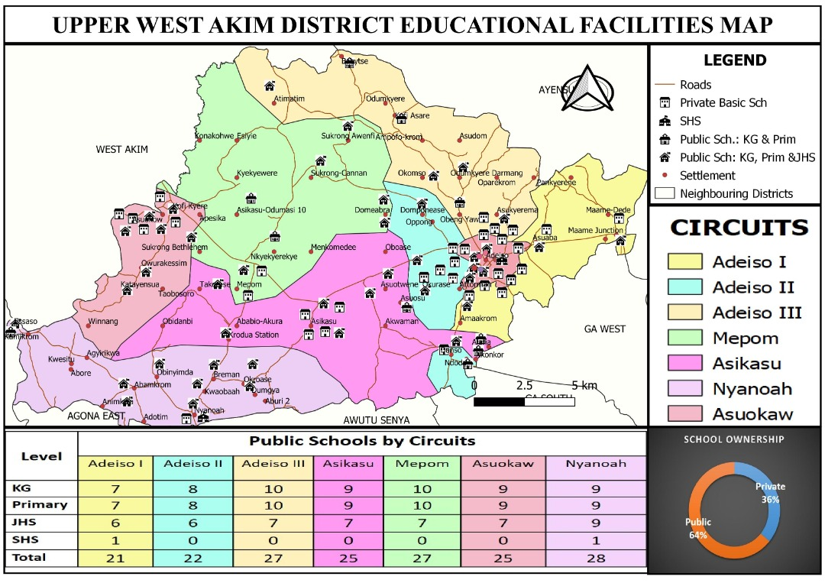

1.10: HEALTH CARE
The vision of the Upper West Akim Health Directorate is to ensure that diseases and avoidable deaths are kept to the barest minimum and every citizen has access to quality–driven, result–oriented and close –to–client focused and affordable health service by a well-motivated workforce. The Upper West Akim Health Directorate, working under the Ghana Health Service has the mandate to implement approved health sector polices in such a manner as to ensure access to priority health interventions and to manage prudently resources available for provision of health services.
The directorate has a mission to improve the overall health status of all persons living in the District through provision of access to quality health care delivered in a humane, efficient and effective manner by well-trained, friendly and highly motivated and client oriented personnel in collaboration with all stakeholders.
The directorate is focused on ensuring that all children survive beyond 5 years, pregnant women would have safe deliveries with healthy babies and the general population is empowered with knowledge and screened to prevent or treat communicable and non-communicable diseases.
The District has eight (8) sub-districts namely; Abamkrom, Adeiso, Asikasu, Asuokaw, Mepom, Odumkyere-Darmang, Nyanoa and Okurase sub-districts in terms of health service delivery. Below is the district health map.
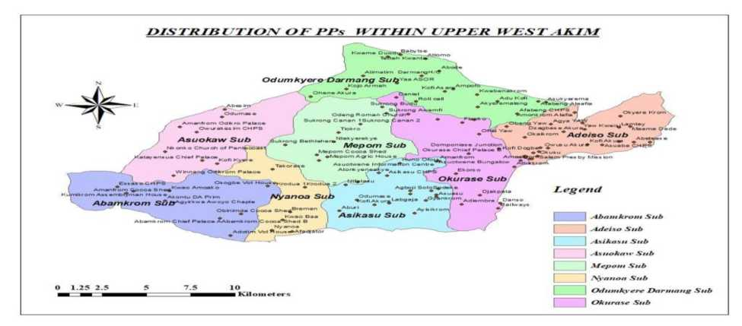

1.10.1: Health Facilities

The District has both public and private health facilities which offer health care delivery services in the District. The highest level or type of health facility in the entire district is the Health Centre and it is only three (3) in numbers and can be located at Adeiso, Mepom and Odumkyere Darmang.

In the remote or rural areas where accessibility to these health centers is a challenge, the health facility type provided is the CHPS Compound. These CHPS Compounds are inadequate in number since the district has greater number of rural communities. There are currently twenty-eight (28) CHPS zones in the district out of which only seven (7) had permanent physical structures. The table and figure below presents the type and number of health facilities in the district.

Table 8: Types and Number of Health Facilities
Type of Facility | Public | Private | Total
Health Center | 3 | 0 | 3
Demarcated CHPS  Zones | 28 | 0 | 28
CHPS | 28 | 0 | 28
Clinics/maternity  Homes | 0 | 4 | 4
Total | 31 | 4 | 35
Source: DHS Report, 2021.
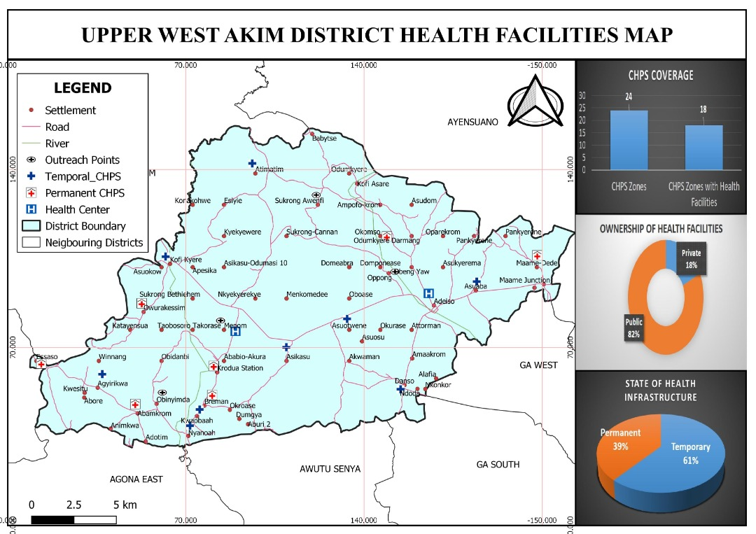From the figure above, it can be seen that the health facilities in the district are grossly inadequate compared to the growth rate of the district population. Also, some of the existing facilities are too are in bad state and needs to be rehabilitated and refurbished.

1.10.2: Types of Health Services

Table 9: Types of Health Services Rendered in Health Center
S/N. | SERVICES | S/N | SERVICES
1 | OPD Services | 9 | Health Promotion(Education)
2 | Antenatal | 10 | Child Welfare Clinic(CWC)
3 | Postnatal | 11 | Comprehensive Abortion Care
4 | Deliveries(Maternity services) | 12 | Immunization(vaccination)
5 | Biomedical Laboratory services | 13 | School Health
6 | Mental Health | 14 | Home Visit
7 | Nutrition | 15 | Referrals
8 | Disease surveillance | 16 | Outreaches

Table 10: Types of Health Services Rendered in CHPS Compounds
S/N. | SERVICES | S/N | SERVICES
1 | OPD Services | 8 | Health Promotion(Education)
2 | Minor Ailment Treatments | 9 | Child Welfare Clinic(CWC)
3 | Antenatal | 10 | Home Visit
4 | Postnatal | 11 | Immunization(vaccination)
5 | Emergency Deliveries(Maternity) | 12 | School Health
6 | Nutrition | 13 | Referrals
7 | Disease surveillance | 14 | Outreaches

Table 11: Staffing in Health Facilities
NO. | HEALTH PERSONNEL | PUBLIC
1 | Doctor | 0
2 | Nurses:
 | • Community Health Nurses | 60
 | • Enrolled Nurses | 59
 | • Professional Nurses(RCHN) | 10
 | • Mental Health Nurses | 9
 | • Public Health Nurses | 2
3 | Midwives | 13
4 | Physician Assistant | 4
5 | Health Assistant | 2
6 | Dispensary Technician | 1
7 | Laboratory Assistant | 1
8 | Biomedical Scientist | 1
9 | Field Technicians | 4
10 | Disease Control Officers | 3
11 | Nutrition Officer | 2
12 | Accountant | 1
13 | Accounts Officer | 0
14 | Health Information Officer | 1
 | TOTAL | 173

1.10.3: Incidence of Diseases

1.10.3.1: Top Ten causes of Outpatient Morbidity - 2020
The data below shows the trend of occurrences of diseases in the District. As indicated in the graph, Malaria continues to top the chart as the most reported case at OPD followed by Acute Respiratory Infections. Hypertension, skin diseases & ulcers and anemia could be seen to be on a rise. Poor sanitation could be attributed to the cause of malaria cases in the district
S/N | CONDITIONS | NO. OF CASES | %
1 | Uncomplicated Malaria Tested Positive | 15288 | 33.7
2 | Upper Respiratory Tract Infections | 6718 | 14.8
3 | Anaemia | 3986 | 8.8
4 | Diarrhoea Diseases | 3548 | 7.8
5 | Typhoid Fever | 2020 | 4.4
6 | Rheumatism / Other Joint Pains / Arthritis | 1611 | 3.5
7 | Hypertension | 1204 | 2.7
8 | Intestinal Worms | 767 | 1.7
9 | Skin Diseases | 679 | 1.5
10 | Acute Urinary Tract Infection | 672 | 1.5
11 | All other Diseases | 8908 | 19.6

The data presented shows the trend of occurrences of diseases in the District. As indicated in the table below, Malaria continues to top the table as the most reported case at OPD followed by Acute Respiratory Infections and Anaemia. Diarrhoea, Anaemia, Typhoid fever, Hypertension, skin diseases and rheumatism could be seen to be on a rise. Poor sanitation and inadequate access to improved toilet facilities could be attributed to the cause of malaria and diarrhoea cases respectively.
Conditions | 2020 | 2019 | 2018 | 2017
Uncomplicated Malaria Tested Positive | 15288 | 18331 | 15151 | 11639
Upper Respiratory Tract Infections | 6718 | 7704 | 6598 | 4240
Anaemia | 3986 | 3633 | 982 | 781
Diarrhoea Diseases | 3548 | 3495 | 1333 | 1223
Typhoid Fever | 2020 | 2263 | 1473 | 428
Rheumatism / Other Joint Pains / Arthritis | 1611 | 1958 | 1148 | 714
Hypertension | 1204 | 1238 | 891 | 631
Intestinal Worms | 767 | 779 | 861 | 685
Skin Diseases | 679 | 748 | 497 | 472
Acute Urinary Tract Infection | 672 | 525 | 334 | 267
All other conditions | 8908 | 8569 | 6354 | 4411
TOTALS | 45401 | 49243 | 35622 | 25491

Table 12: HIV/AIDS
Indicator | 2017 |  |  | 2018 |  |  | 2019 |  |  | 2020
 | Male | Female | Total | Male | Female | Total | Male | Female | Total | Male | Female | Total
No. Receiving Pretest Counseling | 129 | 144 | 273 | 310 | 287 | 597 | 59 | 79 | 138 | 557 | 1215 | 1772
No. Tested | 133 | 139 | 272 | 301 | 287 | 588 | 59 | 79 | 138 | 557 | 1215 | 1772
No. Positive | 7 | 11 | 18 | 7 | 18 | 25 | 4 | 4 | 8 | 11 | 17 | 28
No. Receiving Post-test Counseling | 128 | 141 | 269 | 299 | 287 | 586 | 59 | 79 | 138 | 557 | 1215 | 1772
No. Referred Into Care | 6 | 8 | 14 | 7 | 18 | 25 | 4 | 4 | 8 | 11 | 17 | 28
Source: UWAD-DHS, 2020

Table 13: PMTCT Trend Analysis January – December (2017-2020)
Indicator | 2017 | 2018 | 2019 | 2020
ANC Registrants
No. Receiving Pretest Counseling | 273 | 597 | 138 | 1772
No. Tested | 272 | 588 | 138 | 1772
No. Positive | 18 | 25 | 8 | 28
No. Receiving Post-test Counseling | 269 | 586 | 138 | 1772
No. Tested for Syphilis | 516 | 243 | 1104 | 2561
No. Tested Positive and treated for Syphilis | 13 | 23 | 70 | 90
No. of Pregnant Mothers On ARV | 0 | 0 | 0 | 253
Source: UWADA-DHS, 2020

1.11: WATER SECURITY
The water security in the District can be rated as being good as majority of households (68%) have access to potable water for drinking and for domestic use. Access to potable water in the urban areas is much higher (85%) than that of the rural areas (60%). This is because the population and types of services or functions offered in the urban areas are much higher than in the rural areas. Major towns in the urban areas get their water supply from the Small-Town Pipe Water Systems provided by CWSA and mechanized boreholes provided by the District Assembly and Water Health-Ghana (WHG) in communities such as Adeiso, Mepom, and Asoukaw. Water facilities mostly provided in the rural areas are the boreholes and hand dugs wells.
There are currently three (3) Small-Town Pipe Water Systems, eighteen (18) mechanized boreholes, one hundred and thirty six (136) boreholes and one hundred and fifty five (155) hand dug wells. These water facilities are being managed by Water Management Teams from the various communities.
Though access to potable water in the District is not a major problem, its availability and sustainability cannot be guaranteed due to the following problem.
- Dormant District Water and Sanitation Team (DWST) due to financial and logistical challenges
- Inadequate monitoring and supervision of WSMTs activities and operations
- Poor maintenance and management of water facilities WSMTs
- Lack of transparency and accountability to the community members by WSMTs
- High number of broken down water facilities
- Limited involvement of the District Assembly in implementation of water projects by NGOs, philanthropists and corporate organizations and even some government agencies.
Measured would have to be put in place to ensure these problems are solved and access to safe water guaranteed in the district.

1.12: GENDER EQUALITY
The differential roles of men, women, boys and girls pre-determine their status and influence in every society. The family system and gender parities in the Upper West Akim District show that of male dominance as in any Ghanaian society. Roles and responsibilities are built on the family systems where the male is the bread winner of the house, females are care takers of the home and children play a supportive role.
Male dominance however does not reflect in the system of inheritance as the District has a matrilineal system where children inherit assets/properties of their uncles including right to the royal throne. This system of inheritance allows women some level of influence in decision making at all platforms as mothers, queen mothers or king makers. Despite this system of inheritance, the major asset (land) for economic activities within the District is predominantly owned by men although women venture into every form of economic activity as the males, most especially in the informal business sector.
The centrality of woman’s role to production and reproduction makes their role crucial as development agents. The traditional role of woman as care takers (of husbands & children) and at the same time co-breadwinners pre-suggest their ability and capabilities of being leaders if given much support and empowerment to play an equal role as the male counterpart. There is the need for the District Assembly to collaborate with its Development Partners to further promote gender equality in the district.

1.13: VULNERABILITY ANALYSIS: POVERTY, INEQUALITY AND SOCIAL PROTECTION

The Upper West Akim District has identified Persons with Disability (PWD), the Aged, Persons Living with HIV/AIDS (PLHIV/AIDS), Orphans & Vulnerable Children, Peasant Farmers and Albinos as the most vulnerable in the District.

1.13.1: The Aged
The Aged constitutes 5.6% (4,870) of the District population. Males constitute 40.4% while females constitute the remaining 59.6%. Most of the aged (79.4%) reside in the rural areas.
The aged population is of much concern because it has implications for health care and social policy. Thus there is the need to make health care accessible and affordable to the aged at all times. The Aged has the past years been enrolled onto PWD and free NHIS interventions by the Department of Social Welfare and Community Development. An exercise under the Department is currently classifying them separately for area specific interventions.
The neglect of the Aged by relatives or family members is a growing issue of concern in the District. There is the need to inculcate savings and investment habit in the people so that they would be able to cater for themselves at old age.

1.13.2: Peasant Farmers
The agricultural sector is the main backbone of the District; employing a majority of the economically active population who are peasant farmers and depend on unreliable rainfall patterns. The vulnerability of peasant farmers is been worsened by difficult land tenure systems, poor market prices for farm inputs, high cost of farm inputs, inadequate agriculture extension services and lack of storage facilities that represent dominant shocks affecting incomes, availability of food and wealth accumulation. Data from the Department of Agriculture indicates that 1,352 farmers have lost 2,258acres of land to sand wining due to poor land tenure system or arrangement.

1.13.3: Orphans and Vulnerable Children
The 2010 PHC indicates that the District had 40.7% of its population are between the ages of 0-14 years. This means the District has a lot of children who are dependents. Most of these children become vulnerable because of the District’s high birth rate and inadequate parental control and responsiveness. Cases of teenage pregnancy, child custody and maintenance are the major issues most often reported. The Social Welfare Department of the Assembly will be strengthened to design and implement programmes such as the community sensitization on social welfare issues, regular home visits, provision of educational and medical supports to Orphans and vulnerable children, among others to address these problems.

1.13.4: Persons with Disability (PWD)
Data from 2010 PHC report shows that the district has a population of 2,926 with disabilities. This represents 3.4% of the entire district population. The distribution of persons with disabilities by types of disability indicates that 37.7%, have sight impairment out of the population with disabilities, followed by physical disability 35.2%. This makes sight and physical disability the most common types of disability in the district. Comparatively, there is a little difference between persons with speech disability and persons with hearing disability. People with speech disability represent 19.6% compared to 19.2% of persons with hearing disability. This difference could be due to the fact that hearing and speech disabilities are closely related. Though the disability population is not so high in the district, there is no established institution that support the needs of these PWDs aside the District Assembly. The District Assembly through the Department of Social Welfare and Community Development have supported not more than 15% of the disability population through the disbursement of the PWDs District Assembly Disability Fund which is to enable them to engage in economic/income generating activities. The District Assembly needs to collaborate with more development partners and philanthropists to provide supports that meet the needs of these PWDs

1.13.5: Persons Living with HIV/AIDS (PLHIV/AIDS)

There are people living with HIV and AIDS in the District who are also vulnerable. Unfortunately, the District does not have a full functioning Anti Retro-Viral Center that will offer full services as well as monitor the welfare of Persons with HIV/AIDS. The establishment of an ART Center coupled with advocacy on stigma against PLHIV in the District will encourage the formation of an association by PLHIV to access support from government and other donors. The Health Directorate has however established an ART Unit at the Antenatal Care Unit of the health Center to offer the needed services to PLHIV within the District. Inadequate office and consultation accommodation at the Health Center is a great challenge that militates against access to HIV/AIDS services in a confidential state. This has made it difficult for PLHIV to access health services regularly and free from fear of stigma. The Health Directorate as a result is unable to keep accurate data on HIV/AIDS cases in the District as PLHIV opt to access services from outside the District for fear of stigma.

1.13.6: Albinos
The Department of Social Welfare and Community Development discovered albinos within the District. Small in number with severe disability features like poor visibility and hearing, this population remains conservative due to stigma but manages to practice peasant farming. They are however beneficiaries under PWD, LEAP and free NHIS interventions.

1.13.7: Natural and Man-Made Disasters
Disaster management in the District is under the jurisdiction of the National Disaster Management Organization (NADMO) and with a high level of support from the District Assembly. The Organization has been involved in carrying out activities such as education, clean-up exercises, provision of relief items, formation and training of Disaster Volunteer Groups (DVGs) aimed at reducing vulnerability and impact of this disasters.
Hazards or disasters identified in the district include pest and insect infestation, disease epidemics (cholera), lightening, rainstorms, windstorms, bushfires and domestic fires. Every year, the district is plagued with these hazards which affect some proportion of the population negatively hence resulting into disaster.
NADMO is however challenged logistically and financially hence making it very difficult to carry out their core mandate. To address this, financial and human resources would be mobilized both internally and externally to reduce possible future disasters.

1.14: GOVERNANCE

1.14.1: Establishment of the District Assembly

The Upper West Akim District Assembly (U.W.A.D.A) was established as a District Assembly by Legislative Instrument 2126 in 2012 under the decentralization system to take control of the day-to-day running of the district. The District Assembly has been empowered by law to perform executive, deliberative, and legislative functions for the development of the district.

1.14.2: Political Structure of the District Assembly

The General Assembly is the main body in the Assembly responsible for formulating laws and policies in the district. The Membership of the General Assembly stands at forty (40) which is made up of only four (4) females and thirty-six (36) males. This is made up of the District Chief Executive who is appointed by the President, Twenty-five (26) elected Assembly Members, Twelve (12) Government appointees and a Member of Parliament.
The Assembly members are elected every four years through the Universal Adult Suffrage. These members are expected to keep close contact with their electoral areas, consult their people on issues discussed at the Assembly and collate their views and opinions and present to the Assembly. However, inadequate funds make it difficult for most of the Assembly members to carry out these responsibilities. As a result, there is no effective grass root participation in local governance in the district. This has resulted in poor community acceptance and ownership of the governance system.
The Assembly members elect one representative among them to serve as the Presiding Member (PM) who presides over the General Assembly meetings. The Presiding Member is elected once every two years and is eligible to stand for re-election for a second term.

1.14.3: Sub-District Structures

The District Assembly has twenty six (26) electoral areas with two (2) area councils. These are:
- Adeiso Area Council (consisting of twelve (12) electoral areas)
- Mepom Area Council (consisting of fourteen (14) electoral areas
The Councils have administrative officers assigned by the Management of the Assembly to serve as secretaries. The Councils are responsible for collecting ceded revenues, implementing bye – laws and performing oversight responsibility over community-initiated projects, among others. The operations of the Councils are however hampered because of lack of office accommodation, logistics, funds, administrative staff and lack of remuneration for members which has resulted into lack of commitment on the part of the Council members, and hence making grassroots participation in local governance a major challenge.

1.14.4: Administrative and Management structure of the Assembly
Administratively, the Chief Executive is also responsible for the day-to-day performance of the Executive functions of the Assembly. He supervises the various departments in the Assembly and is the chief representative of the Central Government in the District.
The next in rank after the Chief Executive is the District Co-ordinating Director (DCD), who is a civil Servant and the Secretary to the General Assembly. The Co-ordinating Director performs administrative functions in the Assembly and reports directly to the Chief executive. The various departmental heads and agencies also report to the Co-ordinating Director.

1.14.5: The Executive Committee
In the Assembly, policy decisions are decided by the General Assembly and then implemented by the Executive Committee. The Committee exercise executive and co-ordinating function of the Assembly and it is chaired by the District Chief executive. The Executive Committee co-ordinates plans and programmes of the sub-Committees and submits them as comprehensive plans of action to the General Assembly. The Committee is in charge of implementing resolutions of the Assembly and oversees the administration of the Assembly in collaboration with the office of the Chief Executive, among others.

1.14.6: Sub-Committees of the District Assembly
The District has seven (7) sub-committees in place. These are:
- Development Planning Sub-Committee
- Social Services Sub-Committee
- Works Sub-Committee
- Finance & Administration Sub-Committee
- Justice and Security Sub-Committee
- Agriculture Sub-Committee
- Environmental Sub-Committee

The Sub-Committees are responsible for collating and deliberating on issues relevant to the Assembly in its deliberative, executive and legislative function. They submit their recommendations to the Executive Committee for consideration, which are later ratified or adopted by the General Assembly.

1.14.7: Other Statutory Committees of the District Assembly
The Assembly also has other committees which performs functions relevant for the day-to-day administration of the Assembly. These committees are:
- Entity Tender Committee (ETC)
- Spatial Planning Committee (SPC)
- District AIDS Committee (DAC)
- District Security Council (DiSeC)
- Public Relations and Complaints Committee (PRCC)
- District Planning Coordinating Unit (DPCU)
- District Audit Committee (DAC)
- District Education Oversight Committee (DEOC)
- Public Relations and Complaints Committee (PRCC)

1.14.8: Decentralized Department of the District Assembly

The District Assembly currently has twelve (12) established departments. These are:
- Central Administration Department
- Department of Education
- Department of Health
- Department of Agriculture
- Department of Physical Planning
- Department of Social Welfare and Community Development
- Department of District Works
- Department of Disaster Prevention and Management
- Department of Finance
- Department of Human Resource Management
- Department of Statistics
- Department of Births and Deaths
The following departments have not yet been established yet due to administrative and bureaucratic bottlenecks:
- Trade and Industry Department
- Natural resources, wildlife conservation, game and forestry department

Other Departments and Agencies of the District Assembly
- Information Service Department
- Electoral Commission
- National Commission for Civic Education (NCCE)
- National Health Insurance Authority (NHIA)
- Youth Employment Agency
- Nation Builders Corps (NaBCO)
- Bureau National Investigation (BNI)
- Ghana Police Service (GPS)

1.14.9: Security
The security of the District is under the auspices of the District Security Council (DiSEC) which is chaired by the District Chief Executive. The Council meets quarterly and during emergencies to deliberate on issues related to public safety. The membership of the DiSEC include the DCE, District Police Commander, Bureau of National Investigation Officer (BNI), Ghana Immigration Service Officer, Ghana National Fire Service Officer, District Coordinator-NADMO and Chairman of Justice and Security Sub-Committee.
Security services or agencies in the district are the Police, Bureau of National Investigation (BNI) and NADMO. The Police enforce law and order in the district. The security situation in the district has always been generally peaceful and calm. Reported security problems at the Police Station are often in connection with issues relating to theft, assault, domestic violence, offensive conduct (threats of death). The major security problem that the district has quite often been grappling with is the activities of sand winners, where people’s farms get destroyed with little or no compensation to the victims, non-reclamation of sand-winning site, and the unknown agenda of a foreigner (Known as Rastaman) who is acquiring/purchasing huge parcels of land all over the district and which is of course making farmers lose their farmlands and also displacing of families.
NADMO on the other hand helps identify disaster prone areas in the district, form and train DVGs, sensitize or create awareness on bush fire and also educate the public on fire, its effects and how to prevent its occurrence.
The problems associated with the security agencies in the district are however inadequate police stations/posts, lack of barracks or accommodation for police officers, lack of public confidence in the police in the district and inadequate/lack of logistics.
There is no Fire Service station or Immigration Service established in the district. The District always depends on West Akim and Nsawam Adoagyiri Municipal Assemblies for such services.
The District does not have any district or local court. Criminal, civil and juvenile cases are mostly referred to courts in other nearby districts. This actually makes access to justice in the district very difficult and also makes the work of other law enforcement agencies cumbersome. There is the need to get all these services established a district.

1.14.10: LOCAL ECONOMIC DEVELOPMENT
The information provided in the 2010 PHC report shows that there were 36,736 persons (15 years and older) in the district that are employed and out of which 18,045 are males and 18,691 are females. The report also revealed that as many as 34,923 representing 95.1 percent are employed in the private informal sector. This means that only 4.9 per cent of persons’ age 15 years and older in the district are employed in the private formal sector.
The private informal sector has therefore the largest employment. There are 18,138 (97%) of women employed in this sector as against 16,785 (93%) males. This means that there are more females employed in the private informal sector than males. Most of these informal sector businesses are micro, small and medium scale enterprises who are engaged in agri-businesses, retail services and manufacturing.
The challenges associated with these businesses include lack/inadequate of credit facilities/start-up capital, informal nature of businesses, inadequate technological and managerial skills, lack/inadequate basic machinery/tools to enhance productivity, poor business development services in the areas of marketing of products, lack of irrigation facilities, lack of storage facilities, poor states of roads and transportation systems. The District Assembly does not also have adequate and reliable data on these businesses because most of them do not apply for business operating permit and other licenses.
To make the private sector an engine of growth for the district, the DA would have to gear its energy towards removing all the bottlenecks local business face by way of formulating and implementing effective and efficient policies and programmes/projects that promotes local economic development.

1.15: SPATIAL ANALYSIS
The spatial analysis deals with the organization of human settlements and the functions they perform that can influence economic and social development in the District. In ensuring that the spatial dimension of the district is considered into the plan, analysis was conducted using the scalogram. This tool is a matrix presentation of the functional structure of settlements by giving an impression about the functions settlements perform in a given area thereby helping in future project allocation for communities. The scalogram was used to determine the centrality and spatial linkages between the settlements and to examine the nature and distribution of all types of facilities available in the District. The services considered include both social and economic facilities in the top twenty (20) largest communities. The selection of the twenty top settlements was based on a projected population for 2021 using the 2010 Population and Housing Census as the base.

Table 14: Top 20 Communities
S/N | Community Name | 2010 PHC | Population Projection
S/N | Community Name | 2010 PHC | 2021 | 2022 | 2023 | 2024 | 2025
1 | Adeiso | 14,600 | 18,394 | 18,784 | 19,183 | 19,590 | 20,006
2 | Asuokaw | 6,514 | 8,207 | 8,381 | 8,559 | 8,740 | 8,926
3 | Mepom | 4,407 | 5,552 | 5,670 | 5,790 | 5,913 | 6,039
4 | Okorase | 3,963 | 4,993 | 5,099 | 5,207 | 5,317 | 5,430
5 | Asuotwene | 3,547 | 4,469 | 4,564 | 4,660 | 4,759 | 4,860
6 | Asikasu | 3,121 | 3,932 | 4,015 | 4,101 | 4,188 | 4,277
7 | Abamkrom | 2,197 | 2,768 | 2,827 | 2,887 | 2,948 | 3,010
8 | Danso | 1,883 | 2,372 | 2,423 | 2,474 | 2,527 | 2,580
9 | Nyanoah | 1,815 | 2,287 | 2,335 | 2,385 | 2,435 | 2,487
10 | Kwasi Nyarko | 1,642 | 2,069 | 2,113 | 2,157 | 2,203 | 2,250
11 | Asuaba | 1,621 | 2,042 | 2,086 | 2,130 | 2,175 | 2,221
12 | Kwao Baah | 1,517 | 1,911 | 1,952 | 1,993 | 2,035 | 2,079
13 | Breman | 1,488 | 1,875 | 1,914 | 1,955 | 1,997 | 2,039
14 | Sukurong-Bethlehem | 1,409 | 1,775 | 1,813 | 1,851 | 1,891 | 1,931
15 | Alafia | 1,356 | 1,708 | 1,745 | 1,782 | 1,819 | 1,858
16 | Krodua Station | 1,079 | 1,359 | 1,388 | 1,418 | 1,448 | 1,479
17 | Attohman | 1,024 | 1,290 | 1,317 | 1,345 | 1,374 | 1,403
18 | Mame Dede | 932 | 1,174 | 1,199 | 1,225 | 1,251 | 1,277
19 | Obeng Yaw | 929 | 1,170 | 1,195 | 1,221 | 1,247 | 1,273
20 | Amaman (Amaakrom) | 909 | 1,145 | 1,170 | 1,194 | 1,220 | 1,246
 | Total | 55,953 | 70,493 | 71,989 | 73,517 | 75,077 | 76,670
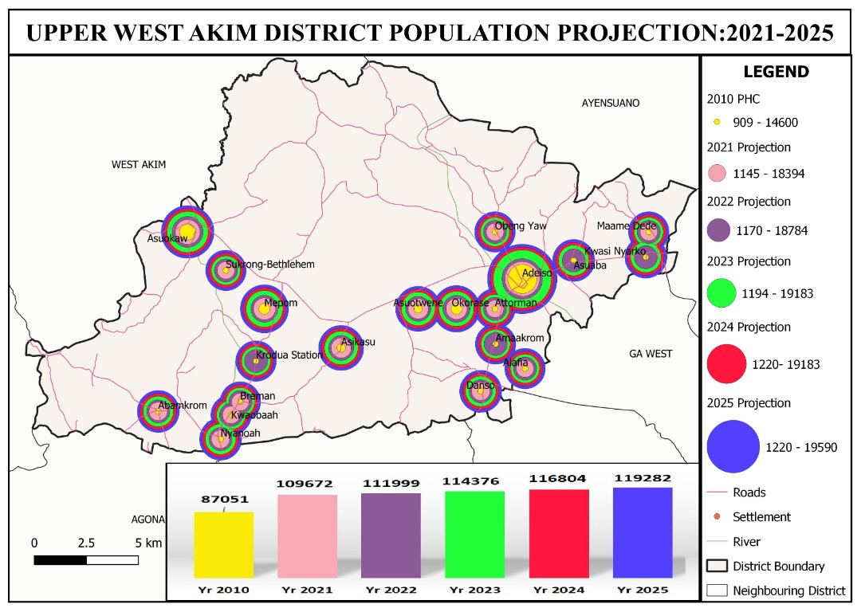

1.16: SCALOGRAM

Table 15: Scalogram
Functions | Population Estimate (2021) | Primary Sch. | JHS | SHS | Borehole Facility | Small Town Water System | HDW | Toilet Facility | Feeder Road | Market | Agric Extension Service | Electricity | CHPS Zone | Health Centre | CHPS Compound | Police Station | Filling/Fuel Station | Lorry Park | Rural Bank | Mortuary | Town/Area Coun. | Telecommunication | Post Office | Community Center | Agric. Office | District Court | Voc./Tech Institute | Restaurant | Guest House | Licensed Chemical Shop | Hotel | Library | District Admin. | Total No. of Functions | Functions as % of expected total | Total Centrality | Hierarchy of settlements
Adeiso | 18,394 | 1 | 1 | 1 | 1 | 1 | 1 | 1 | 1 | 1 | 1 | 1 | 0 | 1 | 0 | 1 | 1 | 1 | 1 | 0 | 1 | 1 | 0 | 0 | 1 | 0 | 0 | 1 | 1 | 1 | 0 | 0 | 1 | 23 | 71.875 | 828.1 | 1st
Asuokaw | 8,207 | 1 | 1 | 0 | 1 | 1 | 1 | 1 | 1 | 1 | 0 | 1 | 1 | 0 | 0 | 0 | 1 | 0 | 0 | 0 | 0 | 1 | 0 | 0 | 0 | 0 | 0 | 0 | 1 | 1 | 0 | 0 | 0 | 14 | 43.75 | 159.5 | 3rd
Mepom | 5,552 | 1 | 1 | 0 | 1 | 1 | 1 | 1 | 1 | 1 | 1 | 1 | 1 | 1 | 0 | 1 | 1 | 0 | 0 | 1 | 1 | 1 | 0 | 0 | 0 | 0 | 0 | 0 | 0 | 1 | 0 | 0 | 0 | 18 | 56.25 | 347.1 | 2nd
Okurase | 4,993 | 1 | 1 | 0 | 1 | 0 | 1 | 1 | 1 | 1 | 1 | 1 | 1 | 0 | 0 | 0 | 1 | 0 | 0 | 0 | 0 | 1 | 0 | 0 | 0 | 0 | 0 | 0 | 0 | 1 | 0 | 0 | 0 | 13 | 40.625 | 100.5 | 3rd
Asuotwene | 4,469 | 1 | 1 | 0 | 1 | 0 | 1 | 1 | 1 | 0 | 1 | 1 | 1 | 0 | 0 | 0 | 0 | 0 | 0 | 0 | 0 | 1 | 0 | 0 | 0 | 0 | 0 | 0 | 0 | 1 | 0 | 0 | 0 | 11 | 34.375 | 67.1 | 4th
Asikasu | 3,932 | 1 | 1 | 0 | 1 | 0 | 1 | 1 | 1 | 0 | 1 | 1 | 1 | 0 | 0 | 1 | 0 | 0 | 0 | 0 | 0 | 1 | 0 | 0 | 0 | 0 | 0 | 0 | 0 | 1 | 0 | 0 | 0 | 12 | 37.5 | 87.1 | 4th
Abamkrom | 2,768 | 1 | 1 | 0 | 1 | 0 | 1 | 1 | 1 | 1 | 1 | 1 | 1 | 0 | 1 | 0 | 0 | 0 | 0 | 0 | 0 | 1 | 0 | 1 | 0 | 0 | 0 | 0 | 0 | 1 | 0 | 0 | 0 | 14 | 43.75 | 142.1 | 3rd
Danso | 2,372 | 1 | 1 | 0 | 1 | 0 | 1 | 1 | 1 | 0 | 1 | 1 | 1 | 0 | 0 | 0 | 0 | 0 | 0 | 0 | 0 | 1 | 0 | 0 | 0 | 0 | 0 | 0 | 0 | 1 | 0 | 0 | 0 | 11 | 34.375 | 67.1 | 4th
Nyanoah | 2,287 | 1 | 1 | 1 | 1 | 0 | 1 | 1 | 1 | 0 | 1 | 1 | 0 | 0 | 0 | 1 | 0 | 0 | 0 | 0 | 0 | 1 | 0 | 1 | 0 | 0 | 0 | 0 | 0 | 1 | 0 | 0 | 0 | 13 | 40.625 | 161.4 | 3rd
Kwesi Nyarko | 2,069 | 1 | 1 | 0 | 1 | 0 | 1 | 1 | 1 | 0 | 0 | 1 | 1 | 0 | 1 | 1 | 1 | 0 | 0 | 0 | 0 | 1 | 0 | 0 | 0 | 0 | 0 | 0 | 0 | 1 | 0 | 0 | 0 | 13 | 40.625 | 121.1 | 3rd
Asuaba | 2,042 | 1 | 1 | 0 | 1 | 0 | 1 | 1 | 1 | 1 | 0 | 1 | 1 | 0 | 0 | 0 | 1 | 0 | 0 | 0 | 0 | 1 | 0 | 0 | 0 | 0 | 0 | 0 | 1 | 1 | 0 | 0 | 0 | 13 | 40.625 | 126.1 | 3rd
Kwao Baah | 1,911 | 1 | 1 | 0 | 1 | 0 | 1 | 1 | 1 | 0 | 0 | 1 | 0 | 0 | 0 | 0 | 0 | 0 | 0 | 0 | 0 | 1 | 0 | 0 | 0 | 0 | 0 | 0 | 0 | 1 | 0 | 0 | 0 | 9 | 28.125 | 50.4 | 4th
Breman | 1,875 | 1 | 1 | 0 | 1 | 0 | 1 | 1 | 1 | 0 | 0 | 1 | 1 | 0 | 1 | 0 | 0 | 0 | 0 | 0 | 0 | 1 | 0 | 0 | 0 | 0 | 0 | 0 | 0 | 1 | 0 | 0 | 0 | 11 | 34.375 | 84.5 | 4th
Sukurong-Bethlehem | 1,775 | 1 | 1 | 0 | 1 | 0 | 1 | 1 | 1 | 0 | 1 | 1 | 0 | 0 | 0 | 0 | 0 | 0 | 0 | 0 | 0 | 1 | 0 | 1 | 0 | 0 | 0 | 0 | 0 | 0 | 0 | 0 | 0 | 10 | 31.25 | 85.5 | 4th
Alafia | 1,708 | 1 | 0 | 0 | 1 | 0 | 0 | 0 | 1 | 0 | 0 | 1 | 0 | 0 | 0 | 0 | 0 | 0 | 0 | 0 | 0 | 1 | 0 | 0 | 0 | 0 | 0 | 0 | 0 | 1 | 0 | 0 | 0 | 6 | 18.75 | 31.8 | 5th
Krodua Station | 1,359 | 1 | 1 | 0 | 1 | 0 | 1 | 1 | 1 | 0 | 1 | 1 | 1 | 0 | 1 | 0 | 0 | 0 | 0 | 0 | 0 | 1 | 0 | 0 | 0 | 0 | 0 | 0 | 0 | 1 |  | 0 | 0 | 12 | 37.5 | 92.1 | 4th
Attohman | 1,290 | 0 | 0 | 0 | 1 | 0 | 1 | 0 | 1 | 0 | 1 | 1 | 0 | 0 | 0 | 0 | 0 | 0 | 0 | 0 | 0 | 1 | 0 | 0 | 0 | 0 | 0 | 0 | 0 | 1 | 0 | 0 | 0 | 7 | 21.875 | 38.8 | 5th
Mame Dede | 1,174 | 0 | 0 | 0 | 1 | 0 | 1 | 0 | 1 | 0 | 1 | 1 | 0 | 0 | 0 | 0 | 0 | 0 | 0 | 0 | 0 | 1 | 0 | 0 | 0 | 0 | 0 | 0 | 0 | 0 | 0 | 0 | 0 | 6 | 18.75 | 28.0 | 5th
Obeng Yaw | 1,170 | 1 | 0 | 0 | 1 | 0 | 1 | 0 | 1 | 0 | 0 | 1 | 0 | 0 | 0 | 0 | 0 | 0 | 0 | 0 | 0 | 1 | 0 | 0 | 0 | 0 | 0 | 0 | 0 | 0 | 0 | 0 | 0 | 6 | 18.75 | 31.1 | 5th
Amaman (Amaakrom) | 1,145 | 0 | 0 | 0 | 1 |  | 1 | 0 | 1 | 0 | 1 | 1 | 0 | 0 | 0 | 0 | 0 | 0 | 0 | 0 | 0 | 1 | 0 | 0 | 0 | 0 | 0 | 0 | 0 | 1 | 0 | 0 | 0 | 7 | 21.875 | 38.8 | 5th
Total of service |  | 17 | 15 | 2 | 20 | 3 | 19 | 15 | 20 | 6 | 13 | 20 | 11 | 2 | 4 | 5 | 6 | 1 | 1 | 1 | 2 | 20 | 0 | 3 | 1 | 0 | 0 | 1 | 3 | 17 | 0 | 0 | 1
Central Index |  | 100 | 100 | 100 | 100 | 100 | 100 | 100 | 100 | 100 | 100 | 100 | 100 | 100 | 100 | 100 | 100 | 100 | 100 | 100 | 100 | 100 | 100 | 100 | 100 | 100 | 100 | 100 | 100 | 100 | 100 | 100 | 100
Weight General Score |  | 5.9 | 6.7 | 50.0 | 5.0 | 33.3 | 5.3 | 6.7 | 5.0 | 16.7 | 7.7 | 5.0 | 9.1 | 50.0 | 25.0 | 20.0 | 16.7 | 100.0 | 100.0 | 100.0 | 50.0 | 5.0 |  | 33.3 | 100.0 | ## | ## | 100.0 | 33.3 | 5.9 | ### | ## | 100.0
The categorisation of the hierarchy of settlements was based on the centrality index of each settlement, and not merely the number of functions or percentage functions of the settlement. The centrality index or total weighted centrality of a settlement is the summation of the weighted centrality of the services in each settlement. A cut off point was determined to depict the order of settlements. The first order settlement, also known as level one, must have a centrality index or total centrality above 400, level 2 and 3 settlements must have a score of 399 to 200 and 199 to 100 respectively. Level 4 settlements must have score of 99 and 50 and level 5 settlements below 50.
Adeiso and Mepom communities, with a population of 18,394 and 5,552 respectively emerged as the only 1st and 2nd level settlements respectively. They both have 23 and 18 respectively out of the 32 functions considered. Asuokaw, Nyanoah, Abamkrom, Asuaba and Kwesi Nyarko settlements qualified to be level 3. Krodua, Asikasu, Sukrong Bethlehem, Breman, Danso and Asuotwene were found to be level 4. The level 5 settlements were Amaaman, Attokrom, Obeng Yaw and Maame Dede.

